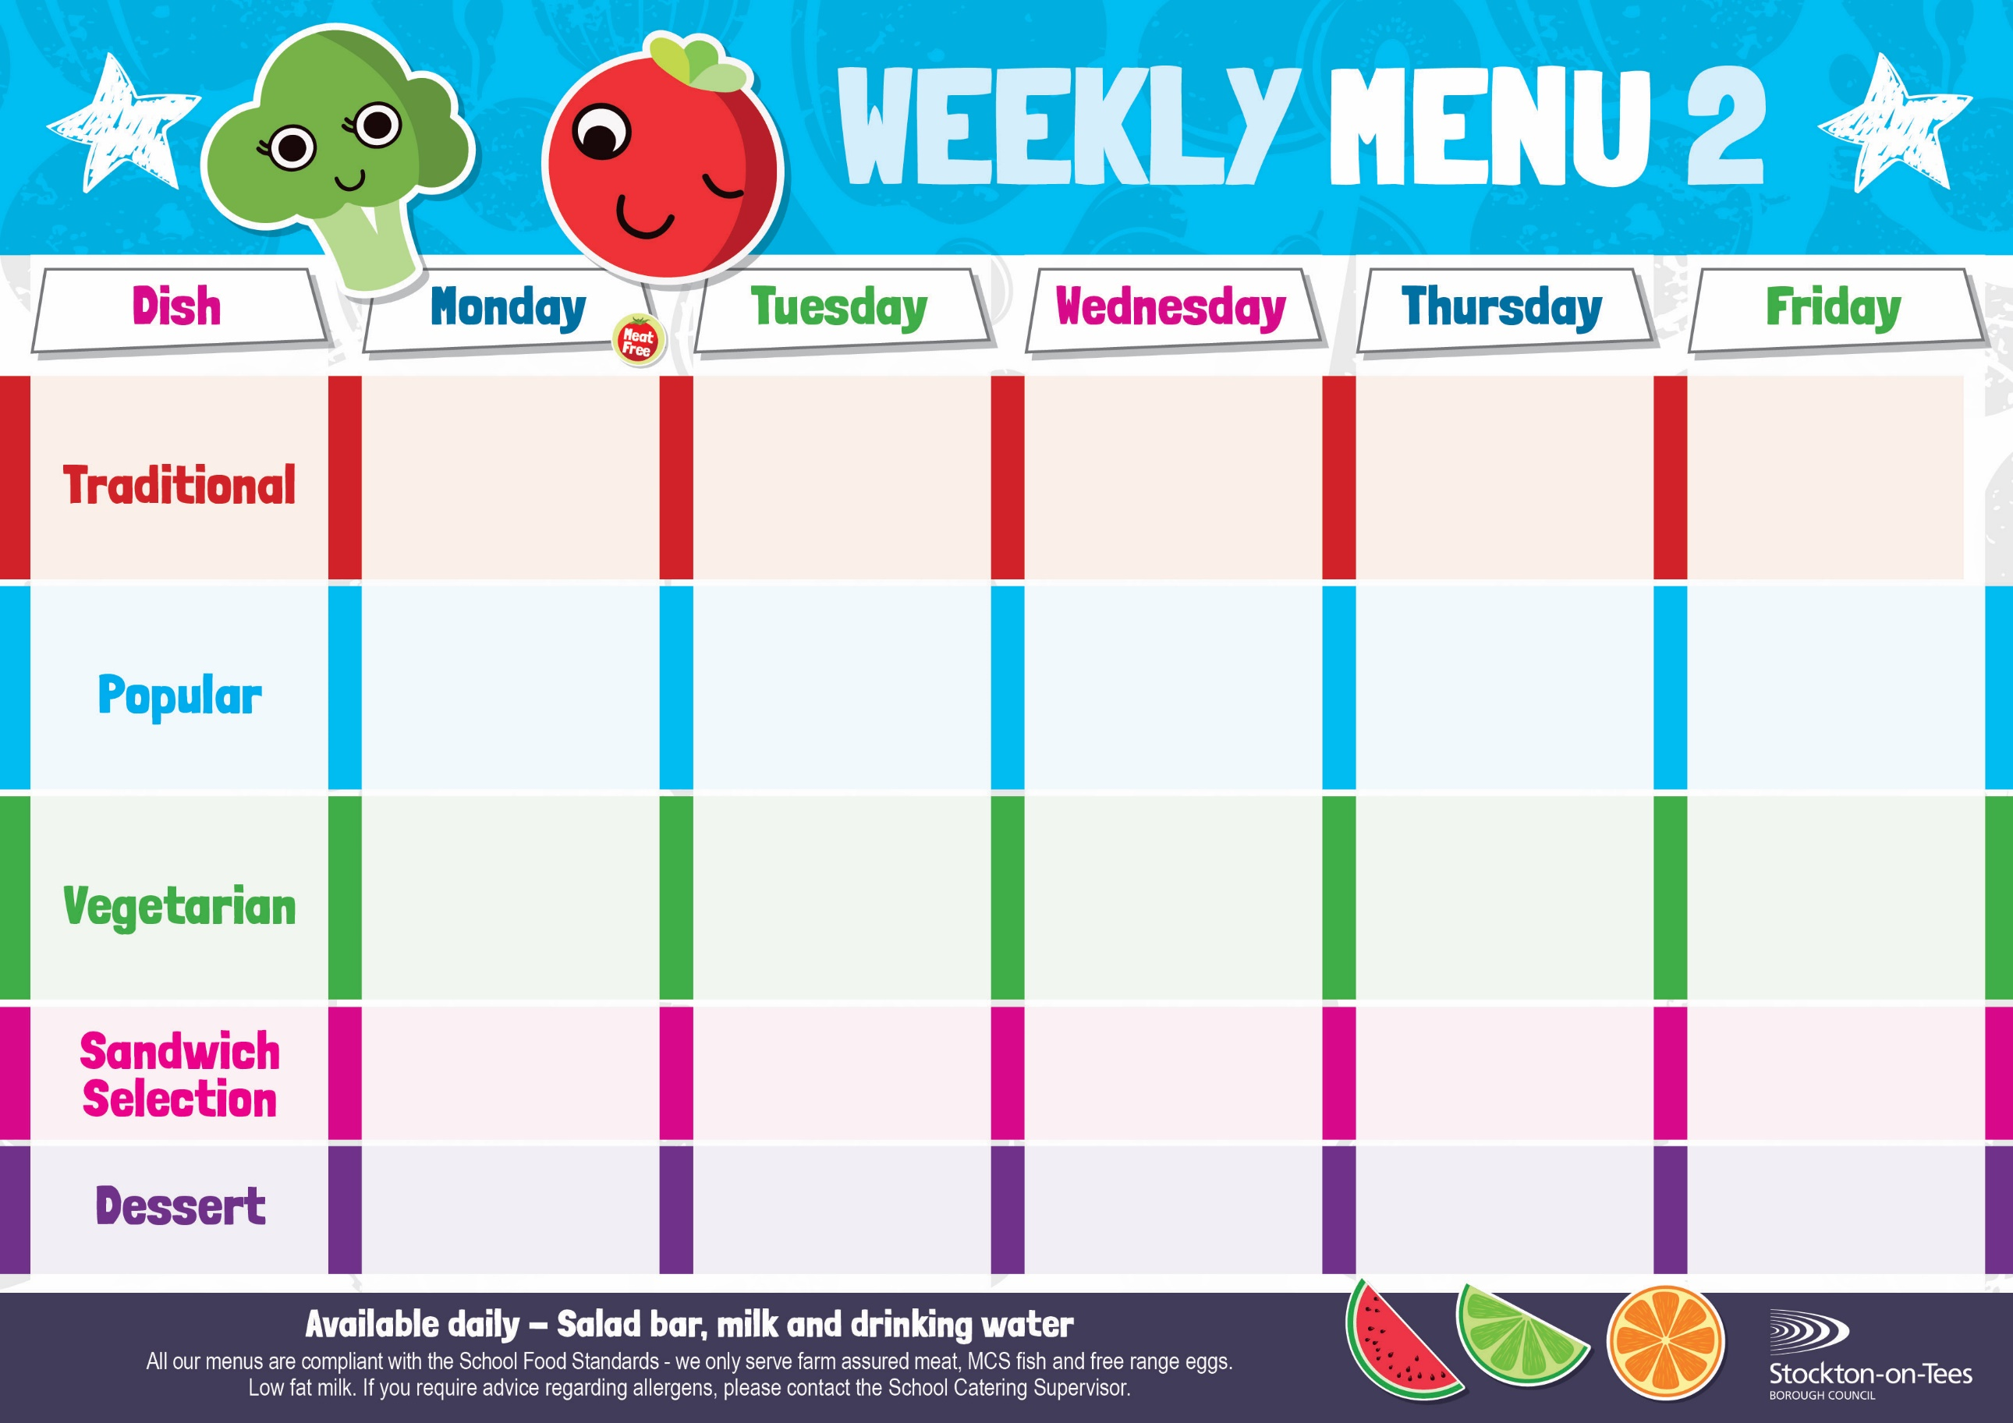
Weeks beginning 8th & 29th September, 20th October, 17th November & 8th December, 2025

Quorn Burger
in a Bun
Roasted Potatoes
Baked Beans
Sweetcorn

Salmon & Sweet Potato Fishcake
Roasted Potatoes
Baked Beans
Sweetcorn

Beef Burger in a Bun Roasted Potatoes
Baked Beans
Sweetcorn
Cheese

Roasted Potato

Cheese Quiche
Oven Baked Chips
Garden Peas
Baked Beans

Macaroni Cheese
Homemade Herby Bread
Garden Peas
Quorn Bolognaise
Homemade Garlic Bread
Broccoli & Carrots

Diced Quorn Curry
& Rice
Mixed Vegetables
Mini Cheese Slice
Baked Jacket Potato
Baked Beans

Sausage Roll
Potato Wedges Baked Beans
Jam Sponge &
Custard Sauce
Jelly
Homemade Biscuit &
Fresh Fruit

Creamy Rice Pudding &
Jam Sauce
Ice Cream
Homemade Biscuit &
Fresh Fruit
Pineapple Upside Down & Custard Sauce
Cup Cake
Homemade Biscuit &
Fresh Fruit
Vanilla Sponge &
Custard Sauce
Choc Chip Cookie
Homemade Biscuit &
Fresh Fruit
Fish Goujons
Oven Baked Chips
Garden Peas
Baked Beans

Spaghetti Bolognaise
Homemade Garlic Bread
Broccoli
Carrots
Chocolate Crunch &
Custard Sauce
Decorated Iced Sponge
Homemade Biscuit &
Fresh Fruit
Tuna Mayonnaise
Oven Baked Chips
Tuna Mayonnaise
Potato Wedges

Roast Ham
Baked Jacket Potato
App
Egg Mayonnaise
Roasted Potatoes

Homemade Pizza
Roasted Potatoes
Garden Peas
Baked Beans

Chicken Curry & Rice
Mixed Vegetables

