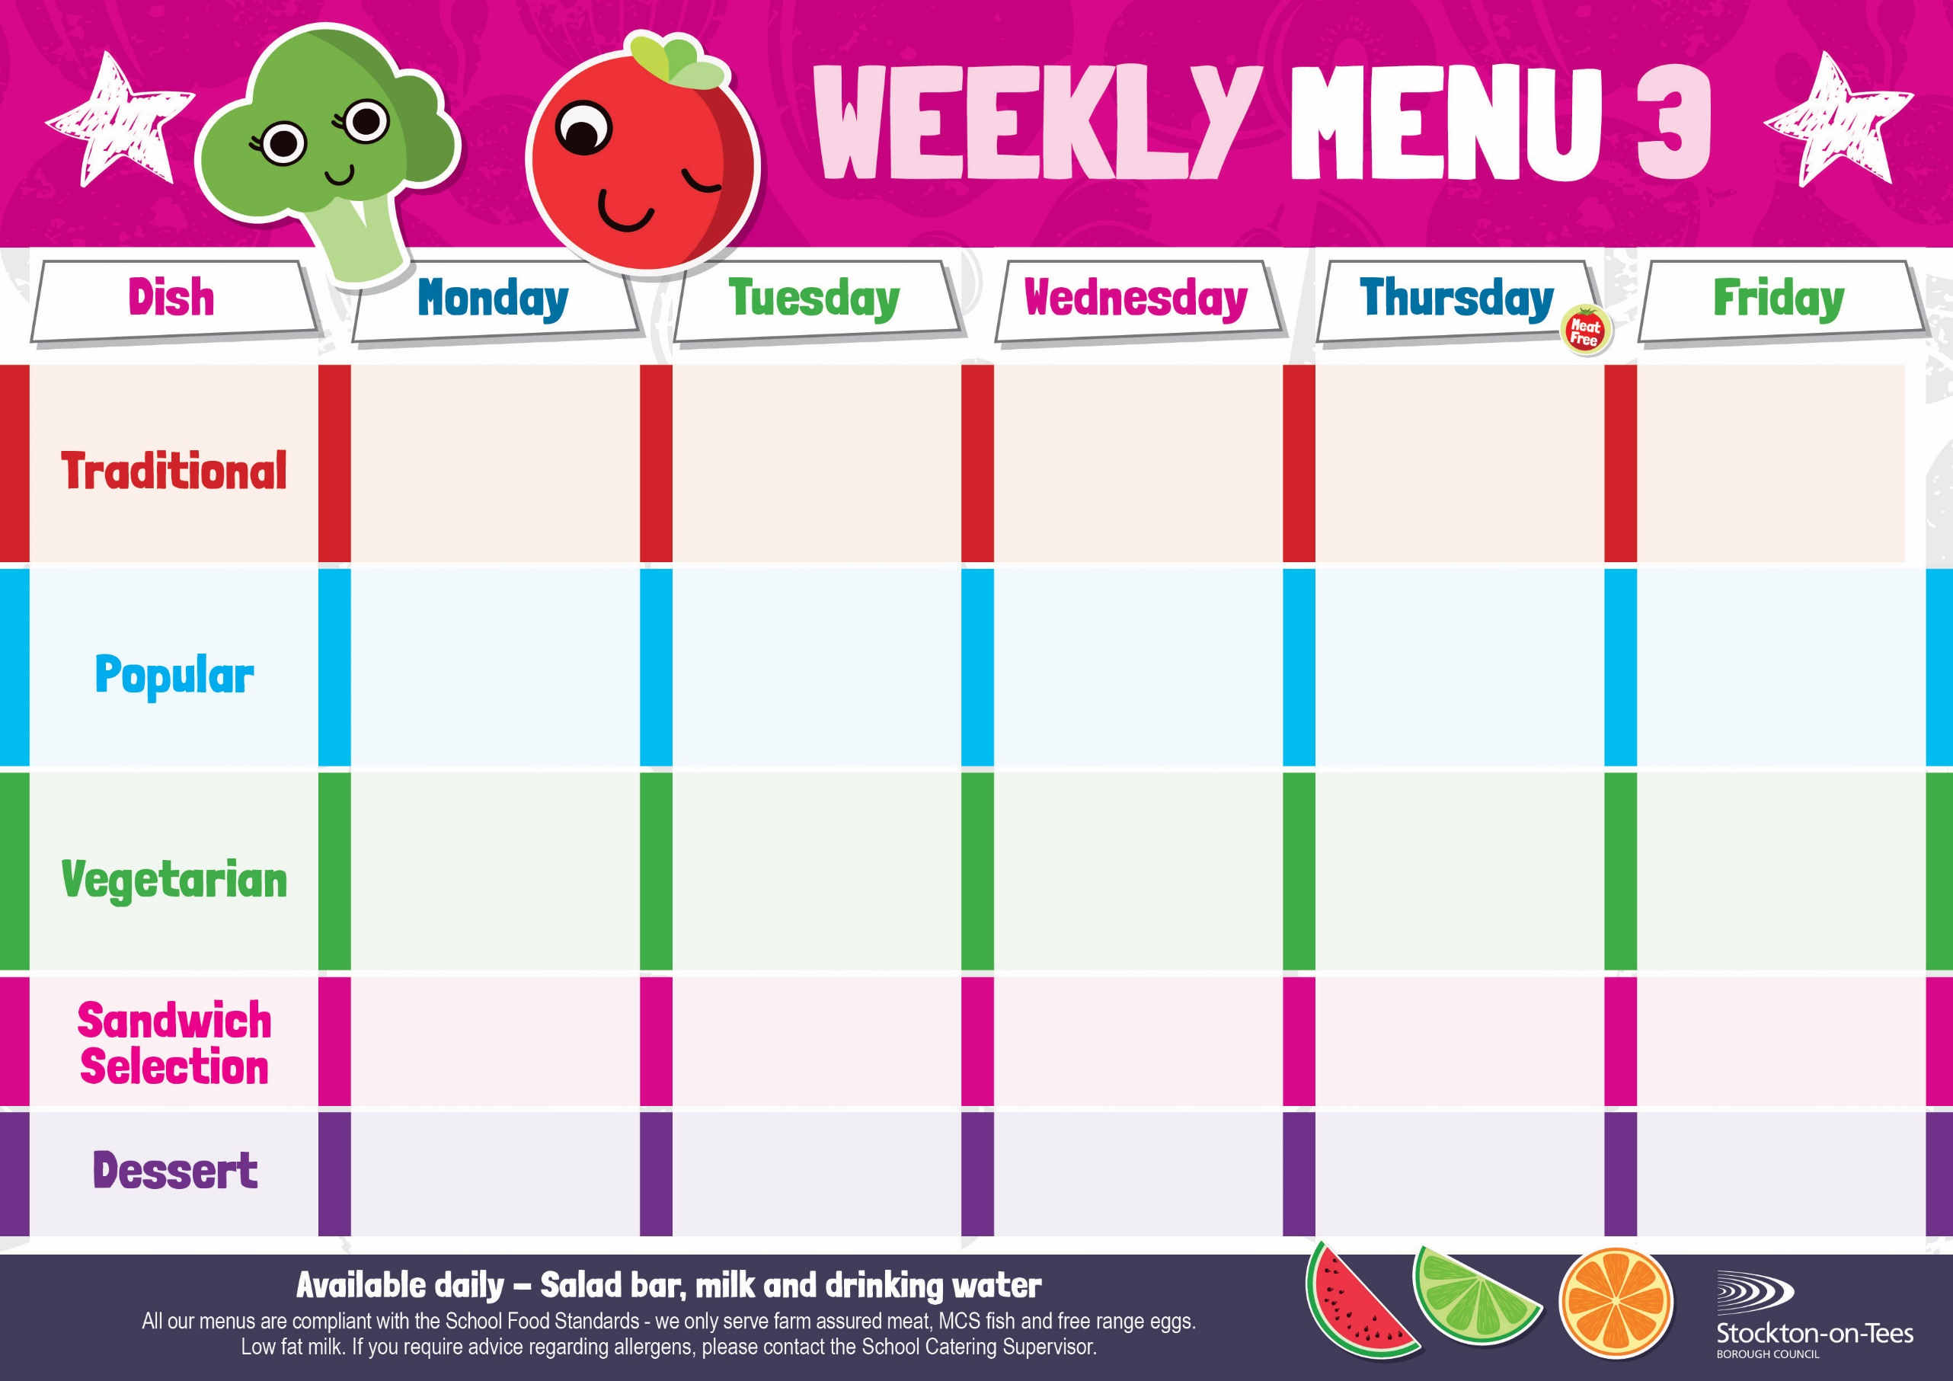
Corned Beef Pie
Creamed Potatoes
Broccoli & Carrots

Fish Star
Potato Wedges
Garden Peas
Baked Beans

Pork & Carrot Meatballs in Tomato Sauce
Homemade Garlic Bread
Broccoli & Carrots
Sausage in a Bun
Roasted Potatoes
Baked Beans

Roast Ham
Potato Wedges
Vegan Meatballs in Tomato Sauce
Homemade Garlic Bread
Broccoli & Carrots

Baked Jacket Potato with Cheese & Baked Beans
Cheese & Onion Roll
Potato Wedges
Baked Beans

Vegan Dippers
Potato Wedges
Garden Peas
Baked Beans

Harry Ramsden
Fish Fillet
Oven Baked Chips
Mushy Peas &
Baked Beans
Weeks beginning 15th September, 6th October, 3rd & 24th November & 15th December, 2025

Cornflake Tart &
Custard Sauce
Ice Cream
Homemade Biscuit &
Fresh Fruit

Jam Roly Poly &
Custard Sauce
Crispy Cake
Homemade Biscuit &
Yoghurt

Lemon Sponge & Custard Sauce
Jelly
Homemade Biscuit &
Fresh Fruit

Creamy Rice Pudding
with Jam Sauce
Cup Cake
Homemade Biscuit &
Yoghurt
Chocolate Cake &
Custard Sauce
Iced Bun
Homemade Biscuit &
Fresh Fruit
Tuna Mayonnaise
Roasted Potatoes
Cheese
Baked Jacket Potato
Tuna Mayonnaise
Oven Baked Chips
Egg Mayonnaise

Potato Wedges
Quorn Sausage
in a Bun
Roasted Potatoes
Baked Beans

Breaded Chicken Breast Fillet
Potato Wedges
Garden Peas
Baked Beans

Baked Jacket Potato with Tuna

Homemade Pizza
Potato Wedges
Baked Beans
Minced Beef & Dumplings
Creamed Potatoes
Cabbage
Diced Swede

