20th January 2025
Dear Parents and Carers,
Update on Building Renovation – Phase 3
We are pleased to update you on the progress of our building renovation works. Phase 3 is currently going to plan, and we remain on track for completion by the end of May 2026. This timeline will allow us sufficient time to set up the new hall, dining hall, reception area, and other facilities without it impacting the normal running of school.
Osborne Building Works
As part of Phase 3, a lot of exciting improvements are happening across the school. Builders have refreshed the walls throughout the building and added a modern metal stud system for extra strength. The roof has been insulated to help keep the school warmer in winter and cooler in summer, while also reducing energy use. New roofs have been built to better connect different areas of the school, and a brand-new main entrance has been created to meet modern safety and accessibility standards. Builders have also added openings with steel supports where needed, fitted special acoustic materials between classrooms to help children concentrate, and are installing a new kitchen with a modern ventilation system to improve mealtimes for everyone.
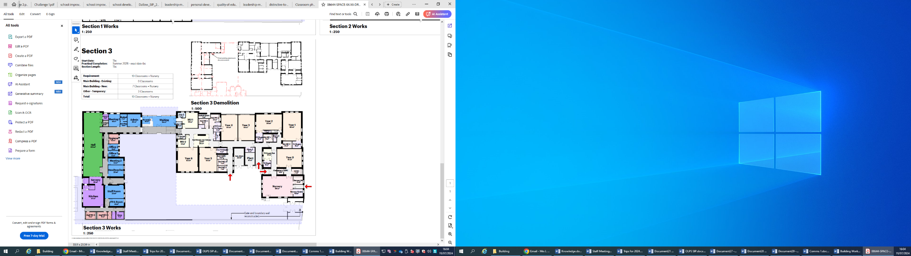
This is the layout of what Phase 3 will look like once it is completed. It will give school a purpose build reception and waiting area, a kitchen, additional meeting rooms, a medical bay, office and other spaces.
The decision has been made to keep the lodge in the playground and the classroom next to it. We hope to repurpose these spaces into a library and craft spaces for the pupils to use and enjoy.
New Main Entrance
Once the builders have completed their work, we will review the timeframe for opening the new main entrance for Years 1 to 6, and will share this information with you as soon as it is confirmed.
Air Raid Shelter

During Phase 2, the first air raid shelter had to be filled in due to the time restraints of getting the playground ready for pupils to return in September. During a survey, it was discovered that there was more than 1 shelter and if they become uncovered during this phase, we can share this with you in due course.
Early Years (Nursery & Reception)
We are also delighted to confirm that from September 2026, our Nursery and Reception classes will be officially located on the main site, entering through the current main entrance on Marlborough Road.
As part of the move, Nursery and Reception will be closed on Wednesday 15th and Thursday 16th July 2026 to box up the EYFS building. Pupils in EYFS will return as normal on Friday 17th July 2026. This does not impact Year 1 to Year 6. The whole school will then break up on Tuesday 21st July.
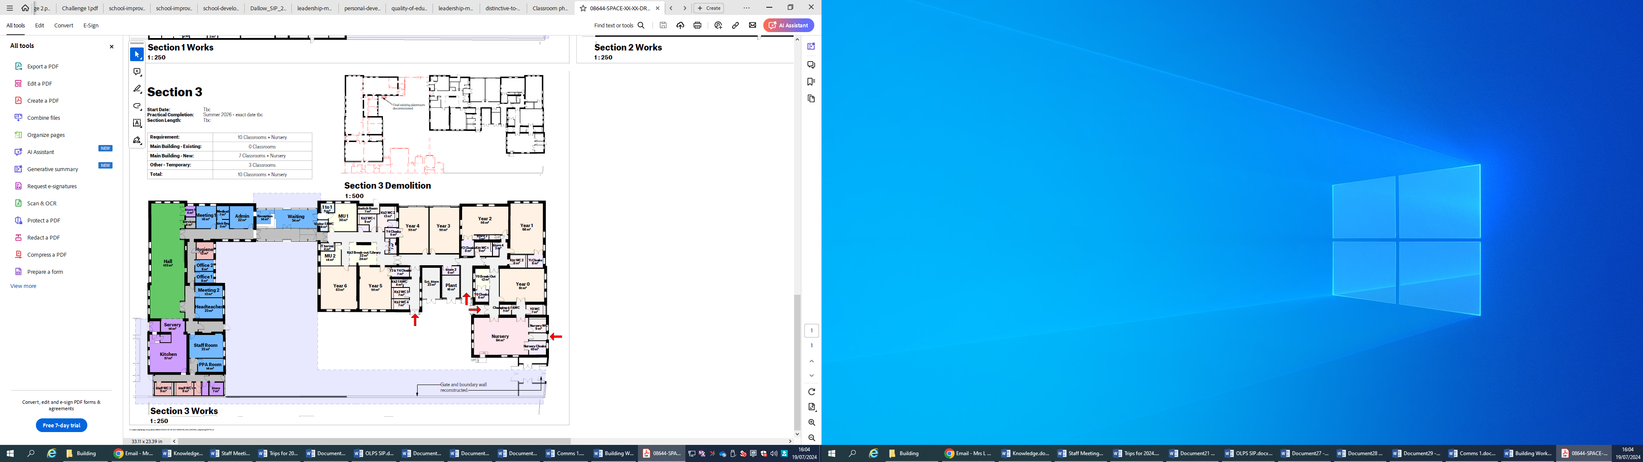
Photographs
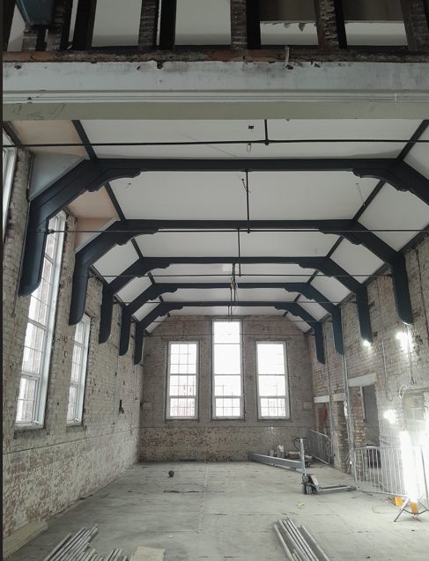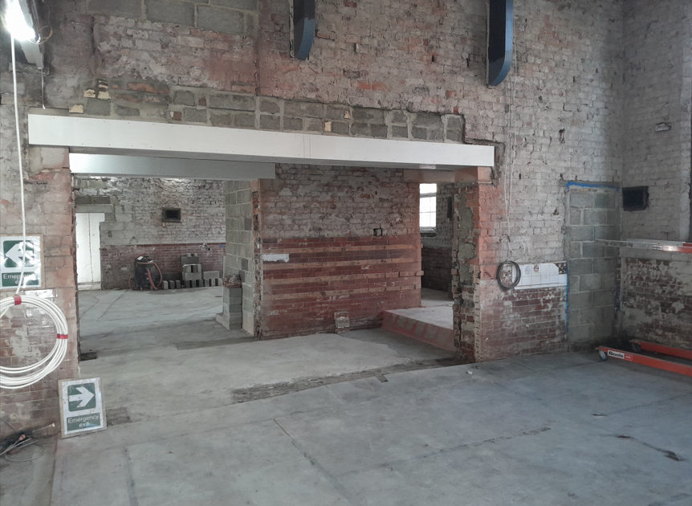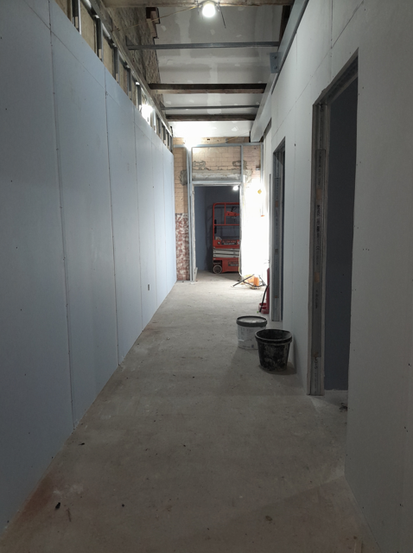
We thank you for your patience and support throughout this process and look forward to welcoming all our pupils to the newly improved facilities.
If you have any questions, please do not hesitate to contact the school office.
Yours sincerely,

Miss L Amerigo

