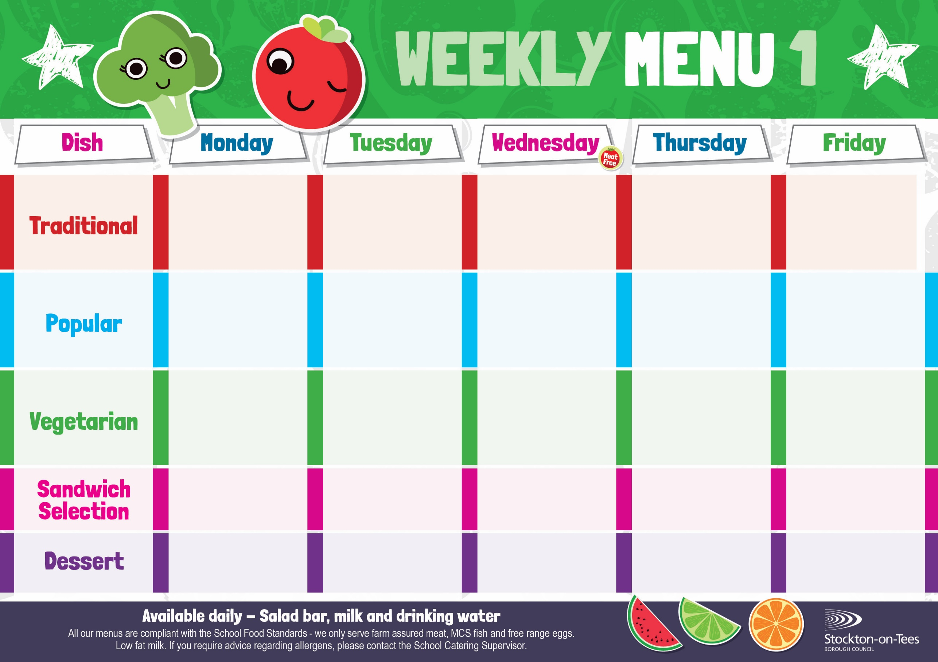

Baked Quorn Sausages
Roasted Potatoes
Sweetcorn
Baked Beans

Baked Cheese & Onion Roll
Oven Baked Chips
Garden Peas &
Baked Beans
Penne Pasta in Tomato Sauce
Homemade Garlic Bread
Broccoli

Roast Ham
Roasted Potatoes
Cheese
Potato Wedges
Tuna Mayonnaise

Baked Jacket Potato

Baked Jacket Potato with Cheese or Baked Beans

Fish Fillet Fingers
Potato Wedges
Baked Beans

Egg Mayonnaise
Roasted Potatoes

Weeks beginning 1st & 22nd September, 13th October, 10th November & 1st December, 2025

Creamy Rice Pudding &
Jam Sauce
Ice Cream
Homemade Biscuit &
Fresh Fruit

Syrup Roly Poly &
Custard Sauce
Iced Bun
Homemade Biscuit &
Fresh Fruit

Ginger Sponge &
Custard Sauce
Fruity Cookie
Homemade Biscuit &
Fresh Fruit

Apple Crumble &
Custard Sauce
Fruity Muffin
Homemade Biscuit &
Fresh Fruit
Choc Chip Sponge &
Custard Sauce
Jelly Whirl
Homemade Biscuit &
Fresh Fruit
Egg Mayonnaise
Oven Baked Chips

Cheese Omelette Roasted Potatoes
Sweetcorn
Baked Beans

Harry Ramsden
Fish Fillet
Oven Baked Chips
Garden Peas &
Baked Beans

Minced Quorn Pie
Creamed Potatoes
Carrots
Cabbage

Baked Sausages
Roasted Potatoes
Garden Peas
Baked Beans

Roast Turkey with Sage & Onion Stuffing
Creamed Potatoes
Broccoli & Swede
Homemade Pizza
Roasted Potatoes
Baked Beans
Sweetcorn
Minced Beef Pie
Creamed Potatoes
Carrots
Cabbage

